**Question 1** Write a program which take 5 inputs from user for different subject's and marks, total it and generate mark sheet using grades ?

**Coding**

subject1=int(input("ENTER Mark Of The First Subject: "))  
subject2=int(input("ENTER Mark Of The Second Subject: "))  
subject3=int(input("ENTER Mark Of The Third Subject: "))  
subject4=int(input("ENTER Mark Of The Forth Subject: "))  
subject5=int(input("ENTER Mark Of The Fifth Subject: "))   
obtainmark = subject1 + subject2 + subject3 + subject4 + subject5;  
print("YOUR OBTAIN MARK",obtainmark)  
average = obtainmark/5  
if(average>=85 and average<=100):  
 print("Your Grade is A+");  
elif(average>=75 and average<85):  
 print("Your Grade is A");  
elif(average>=65 and average<75):  
 print("Your Grade is B+");  
elif(average>=55 and average<65):  
 print("Your Grade is B");  
elif(average>=50 and average<=55):  
 print("Your Grade is C+");  
elif(average>=0 and average<=40):  
 print("Your Grade is F");  
else:  
 print("Strange Grade..!!");

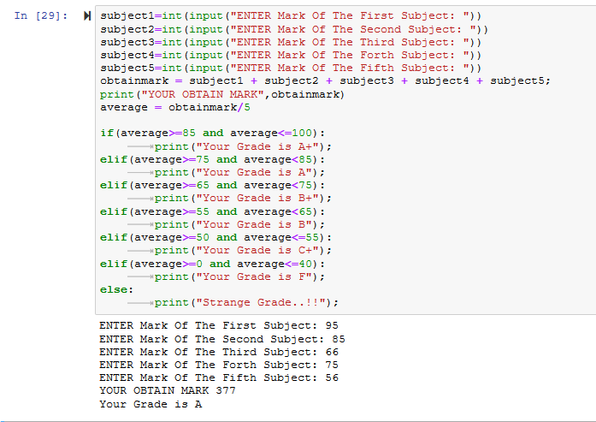

**Question 2** Write a program which take inputs from user and identify that the given number is even or odd?

**Coding**

num = input("Enter any number: ");  
number = float(num);  
if num:  
 check = number%2;  
 if check == 0:  
 print(int(number), "is an even number.");  
 elif check == 1:  
 print(int(number), "is an odd number.");

else:  
 print(number, "is strange.");

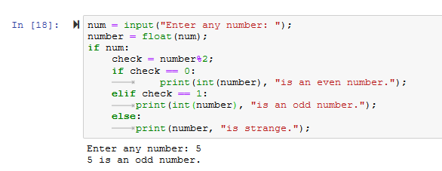

**Question 3** Write a program which print the length of the list?

**Coding**

a = []   
a.append("Ali")   
a.append("Zaeem") a.append("Faisal")   
print("The length of list is: ", len(a))

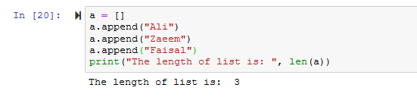

**Question 4** Write a Python program to sum all the numeric item in a list?

**Coding**

lst = [ ]  
num = int(input('How many numbers: '))  
for n in range(num):  
 numbers = int(input('Enter number '))  
 lst.append(numbers)  
print("Sum of elements in given list is :", sum(lst))

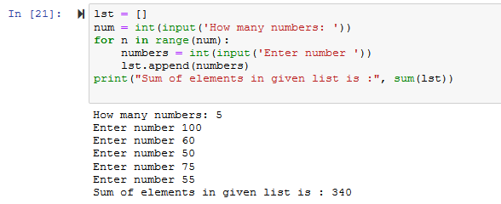

**Question 5** Write a Python program to get largest number from a numeric list.

**Coding**lst = []  
num = int(input('How many numbers: '))  
for n in range(num):  
 numbers = int(input('Enter number '))  
 lst.append(numbers)  
 print("Maximum element in the list is :", max(lst))

**Now find Minimum and Maximum**

lst = []  
num = int(input('How many numbers: '))

for n in range(num):  
 numbers = int(input('Enter number '))  
 lst.append(numbers)

print("Maximum element in the list is :", max(lst), "\nMinimum element in the list is :", min(lst))

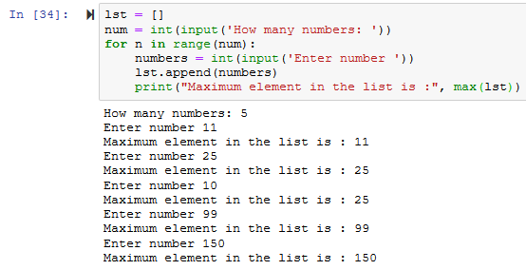

**Question 6** Take a list, say for example this one:

A= [1, 1, 2, 3, 5, 8, 13, 21, 34, 55, 48] and Write a Python that print out all the elements of the list that are less than 5.

**Coding**

a = [1,1,2,3,4,8,13,21,34,55,48]  
def print_less_than_five():  
 for i in range(len(a)):  
 if a[i]<5:  
 print(a[i])  
print_less_than_five()

